Today we inform you about following themes:

New P-Series machines,
W1562P & W1662P 2
This new MLS-Plus series has many new
key features and big advantages for production

New FS703P 4
This new MLS-Plus series has many new
key features and big advantages for production

Appendix 8
Extended subclass list of FS703P

Kind regards

U. Rabe, PE

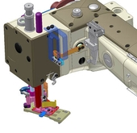
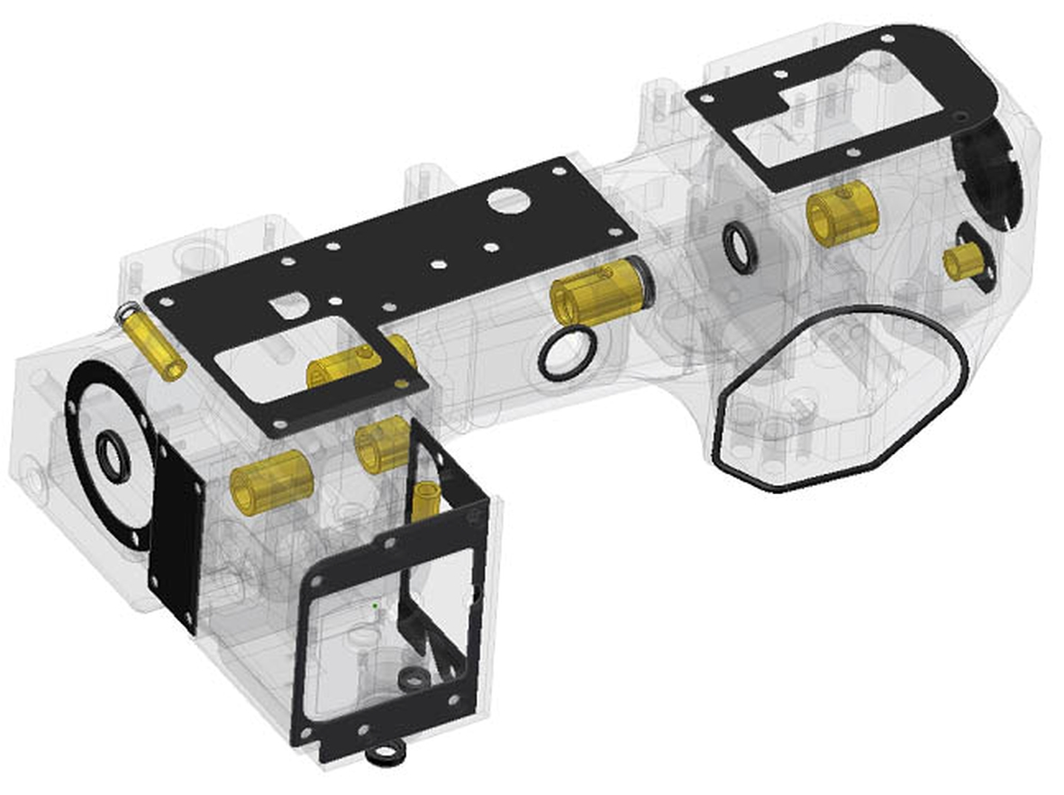

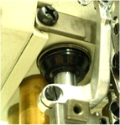

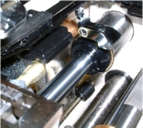

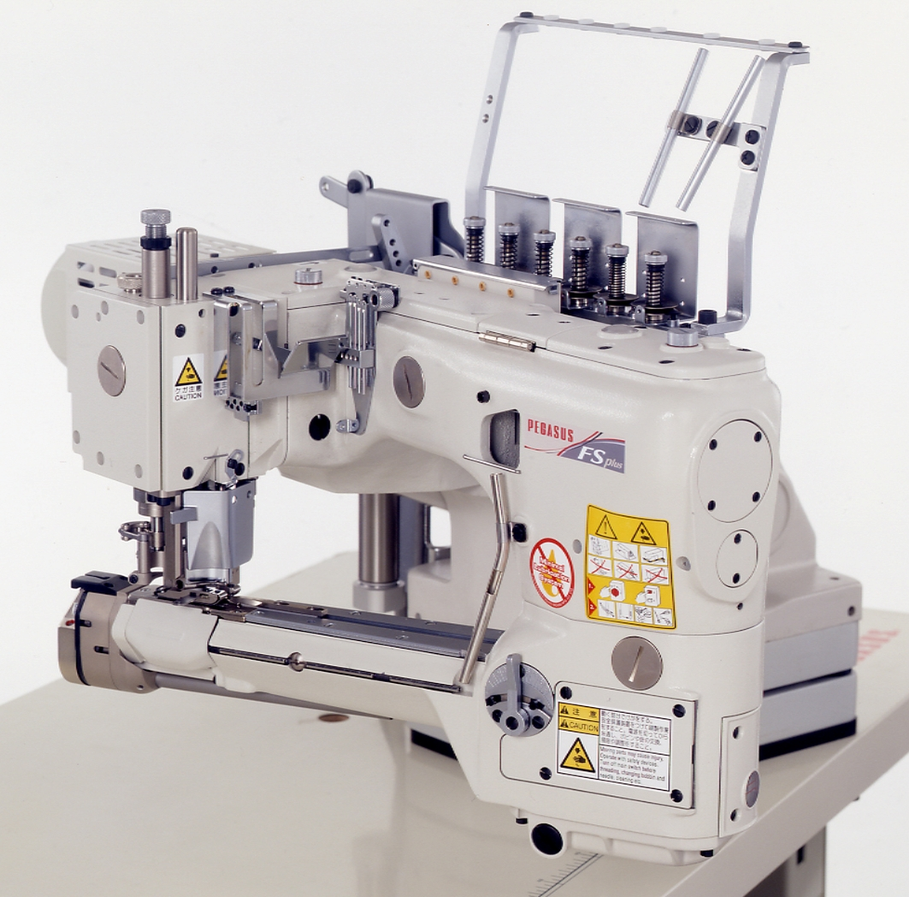

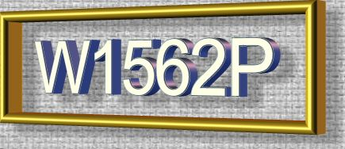

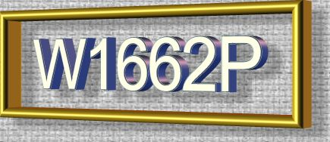

W1562P and W1662P, new economical high - speed interlock machines with

Minimal Lubrication - PLUS

Pegasus is introducing the new minimal lubrication – PLUS series machines, starting with W1562P, W1662P and FS703P.

The improved and advanced oil blocking and MLS-Plus models of W(T) – series are introduced step by step, starting with W1562P and W1662P. The speed of the “P” - machines remains unchanged, which gives big advantages in production, in comparison to so called “DRY” models (overlock machines) of our competitor.

Outstanding new features and technical improvements:

➢ Newest oil seals on needle bar and upper looper shaft bushings (latter one on cylinder bed machines)

- solving any problems of oil stains

- even no oil on needle bar during longer period of no use

- newest oil seals are very durable and last over 1000 hours at 6500 rpm, which is approx. 3 years

- W2600 has additionally the DLC-coated (black colour) needle bar, increasing wear and tear and durability

- various changes have been made in the area of the machine arm and the machine bed

Exceptions:

a, No oil seal on upper needle bar
bushing of WT100 / W1000 / W2000
series (no need, enclosed upper
needle bar bushing)

b, The looper shaft oil seal is only used
on W(T)600 / CW600 / W1600 /
W2600 – series (cylinder bed
machines only).

c, Except W2600S / CW500 / W500-
01D・21・22 / CW500N-01D・21 /
W600-51 / W700L-22 (models are
not adapted with MLS-P)

Explained in more details:

NEW
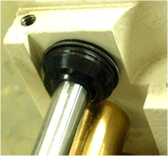

- new oil seal on the needle bar bushing, shape of bushing is different and the bushing has a hole on the upper side for depressurisation
NEW

- new oil seal on the looper bar bushing, shape of bushing is different (only for cylinder bed machines).

NEW
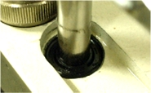

- additional new oil seal on the upper needle bar bushing, shape of bushing is different (on conventional thread take-up)
NEW

- additional minimal lubrication oil pump for needle bar cam and needle bar on W2600 series for automatic and optimum lubrication of the needle bar cam chamber

NEW
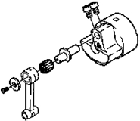

- needle bar stroke switching mechanism for the W200 / W500 / W600 / W1500N / W1600. The CW500N, CW600, W674 and W700(L) use the needle bar stroke fixed type.

As we can see from all the details, W1562P and W1662P show many improvements with many advantages in production, for improved quality, for ease of maintenance and no oil splashing.

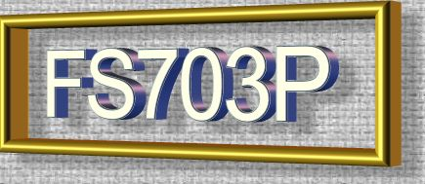

FS700P, new advanced and strongly improved high - speed feed-off-the-arm interlock-stitch machine with

Minimal Lubrication - PLUS

First feed-off-the-arm interlock-stitch machine in the world with fully enclosed needle bar casting, with

Minimal Lubrication – PLUS and many additional new features

Outstanding new features and technical improvements:

➢ The world’s first machine bed, equipped with a completely enclosed needle bar and thread take-up casting

➢ Newest oil seals on needle bar and upper knife holder, top cover shaft and presser foot shaft

- Solving any problems of oil stains

- Even no oil on needle bar during longer period of no use

- Enclosed looper thread take-up mechanism（ wall of casting for separation – only Pegasus)

- Adopted metal sheet gaskets with covers (several times re-usable)

- Equipped with oil seals on the feed bars (only Pegasus)

- Possible to adjust the feed bar “front – rear” position

- Easy change of the moving capacity of carrier & hook

- Rust prevention measurements have been additionally made

- Changing oil viscosity to ISO VG22, same like Overlock machines.

- 2 new subclasses, -G2B and –G2C

Explained in more details:

NEW
Adopted the world’s first machine bed, equipped with a completely enclosed needle bar and thread take-up casting
- Completely enclosed needle bar and thread take-up casting

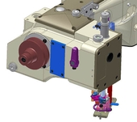

thread take-up lever moved to the right and fully enclosed

NEW

➢ Newest oil seals on needle bar and upper knife holder, top cover shaft and presser foot shaft,
solving any problems of oil stains, even no oil on needle bar during longer period of no use

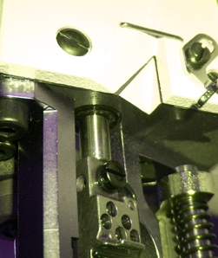

NEW

- Enclosed looper thread take-up mechanism（ wall of casting for separation – only Pegasus)
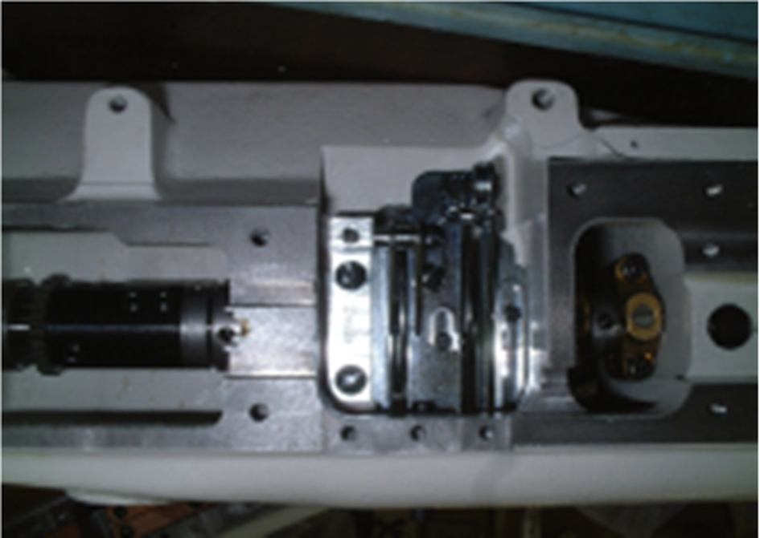

NEW

- Changing the adjustment method of upper knife holder, top cover shaft and foot shaft, due to the change of mechanism.
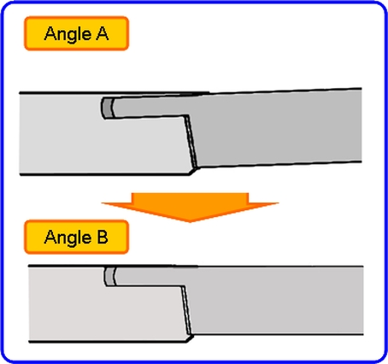

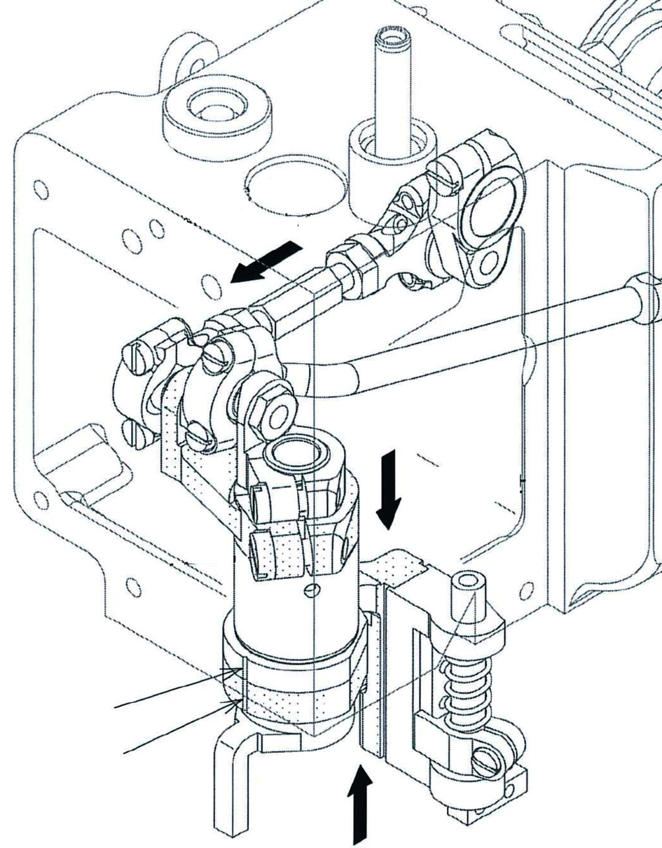

NEW

- New introduced metal sheet gaskets with covers (several times re-usable)

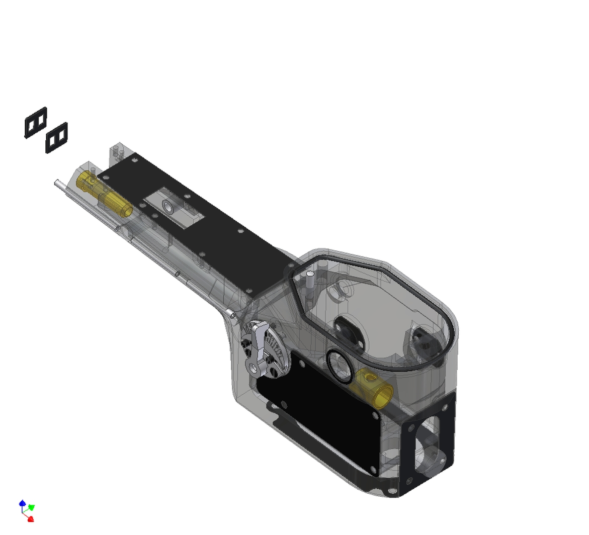

NEW

- Equipped with oil seals on the feed
bars (only Pegasus)

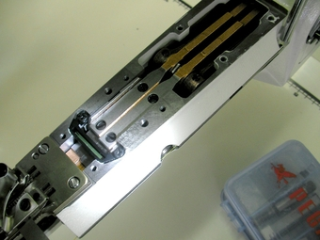
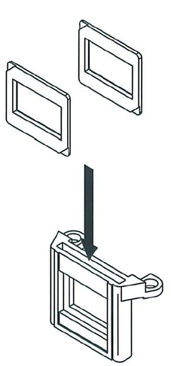

NEW

- Possible to adjust the feed bar “front – rear” position
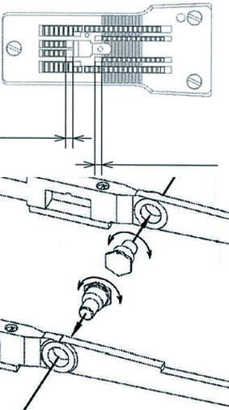
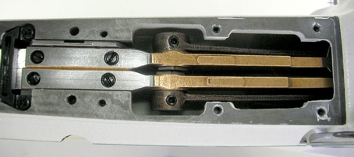
adjustment by eccentric screws

NEW

- Easy change of the moving capacity of carrier & hook on
6.0 mm needle gauge, in order to avoid any skip stitching

NEW

- Rust prevention measurements have been additionally applied on the tension nuts of the upper thread tension plate, the needle plate, the arm bed cover etc.

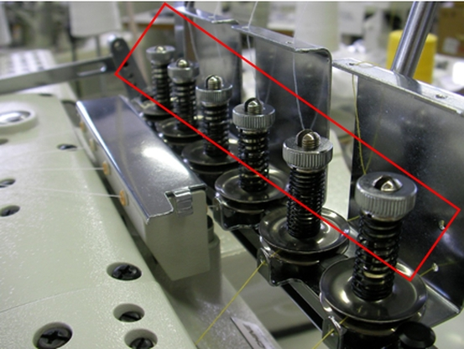

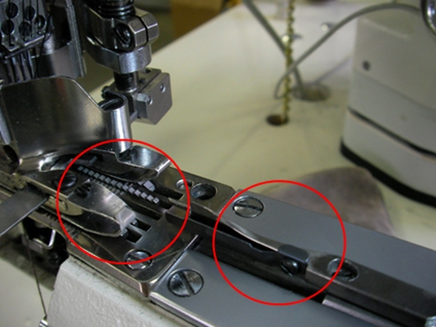

NEW

- Changing oil viscosity to ISO VG22, same like overlock machines.

NEW

- 2 new subclasses, - G2B and – G2C, which are of importance for European markets.

The difference is the depth of the groove in the middle of the presser foot, ready for different applications.

depth of groove of -02GB

depth of groove of -02GC
depth of groove of -02G

presser foot view from front (symbolic)

- Appended new subclasses of “P” –models:

FS701TP-G0
FS701TP-G0/B
“T” = for attaching fly tape
“B” = with binder

FS703P-G2
FS703P-G2C
FS703P-G2B

“-G2” = standard subclass
“-G2C” = with deeper groove
for light and stretchable
fabric
“-G2B” = with deepest groove for
gusset attaching, front
taping on briefs, knit
trunks etc.

As we can see from the all the details, FS703P “Minimal Lubrication – Plus” shows many improvements with many advantages in production, for improved quality, for ease of maintenance
and no oil splashing.

U. Rabe, PE


FS700 / P series
“Oil Barrier” technology
- plus -
FS700 - plus series
● Enhancement of subclasses.
Newly introduced hereunder subclasses.

